**Review of research methodology**

**Short Literature Review of Methodologies Used in Other Studies**

GUI element detection has employed experimental, quantitative, and mixed method methodologies. These approaches typically involve systematic testing and empirical validation.

Daneshvar and Wang (2024) [1] conducted experimental research using advanced deep learning methods (YOLO models), emphasizing quantitative metrics such as accuracy, precision and recall. Their methodology prioritizes objective evaluations using standardized GUI datasets.

Chen et al. (2020) [2] presented a comparative experimental methodology, combining traditional image processing methods with deep learning approaches. They incorporated both quantitative performance metrics and qualitative visual inspection to assess practical usability.

Gu et al. (2023) [3] utilized an experimental methodology that combined quantitative benchmarking (e.g., accuracy and processing speed) with qualitative visual inspection. They highlighted how adaptability within models improved performance, particularly in mobile user interface detection tasks.

Zhao et al. (2022) [4] leveraged deep reinforcement learning in an experimental approach to automate GUI testing processes. They focused primarily on quantitative metrics, evaluating their models rigorously in controlled testing scenarios and benchmarked against existing methods to validate their hypothesis on automated testing effectiveness.

Lastly, Amalfitano et al. (2015) [5] implemented artificial intelligence-based methodologies for GUI testing, employing structured experimental designs focused on quantitative performance validation. Their research aimed to deliver objective insights into automation solutions in software testing environments.

**Distinction Between Academic and Non-Academic Material**

* **Academic Material:** Includes peer reviewed articles, scholarly conference papers, and theses. These sources undergo strict evaluation processes and provide reliable, validated methodologies and empirical evidence.
* **Non-academic Material:** Covers informal resources like blogs, online articles, industry whitepapers, or promotional content. These materials are not peer-reviewed, thus lacking the scholarly validation of academic sources, making them suitable only as supplementary references.

**Recommended Peer Reviewed Articles**

[1] S. S. Daneshvar and S. Wang, "GUI Element Detection Using SOTA YOLO Deep Learning Models," *arXiv preprint arXiv:2408.03507*, 2024. [Online]. Available: <https://arxiv.org/abs/2408.03507>

[2] Z. Chen, X. Xiao, and S. Gao, "Object Detection for Graphical User Interface: Old Fashioned or Deep Learning or a Combination?," *arXiv preprint arXiv:2008.05132*, 2020. [Online]. Available: <https://arxiv.org/abs/2008.05132>

[3] Z. Gu et al., "Mobile User Interface Element Detection via Adaptively Prompt Tuning," *Proceedings of the IEEE/CVF Conference on Computer Vision and Pattern Recognition*, pp. 11155–11164, 2023. [Online]. Available: <https://openaccess.thecvf.com/content/CVPR2023/papers/Gu_Mobile_User_Interface_Element_Detection_via_Adaptively_Prompt_Tuning_CVPR_2023_paper.pdf>

[4] X. Zhao, Y. Cao, and M. Li, "Deep Reinforcement Learning for Automated GUI Testing," *IEEE Transactions on Software Engineering*, vol. 49, no. 5, pp. 1769–1784, 2022. [Online]. Available: <https://ieeexplore.ieee.org/document/9715282>

[5] D. Amalfitano, A. R. Fasolino, P. Tramontana, and N. Amatucci, "Using Artificial Intelligence to Automatically Test GUI," *IEEE Software*, vol. 32, no. 5, pp. 46–53, 2015. [Online]. Available: <https://doi.org/10.1109/MS.2015.104>

**Contextualized Literature and Research Material**

Recent methodologies in GUI detection research prioritize deep learning techniques due to their demonstrated superior performance over traditional methods. Researchers commonly adopt structured experimental designs, ensuring rigorous quantitative evaluation through standardized benchmarks such as accuracy, precision, recall, and processing speed. Qualitative validation such as visual inspection is included to contextualize quantitative findings, thus providing insights relevant to practical applications and usability in software engineering.

**Critical Literature Arguments**

Studies by Daneshvar and Wang [1] and Zhao et al. [4] primarily adopt quantitative benchmarks, offering objective empirical validations but often omit deeper qualitative insights into usability. Conversely, Chen et al. [2] and Gu et al. [3] integrated quantitative performance analysis with qualitative visual validations, providing good quality evaluations yet these studies do not explore in depth the adaptability of models across different GUI complexities and platforms.

Amalfitano et al. [5] focused on AI driven automation but limited their scope primarily to structured and simplified GUI scenarios. The practical adaptability of GUI detection models to dynamically changing and complex interfaces remains less addressed. This creates a knowledge gap offering a valuable direction for future research to explore GUI model robustness and adaptability across diverse contexts and environments.

**Construct a Literature Map.**

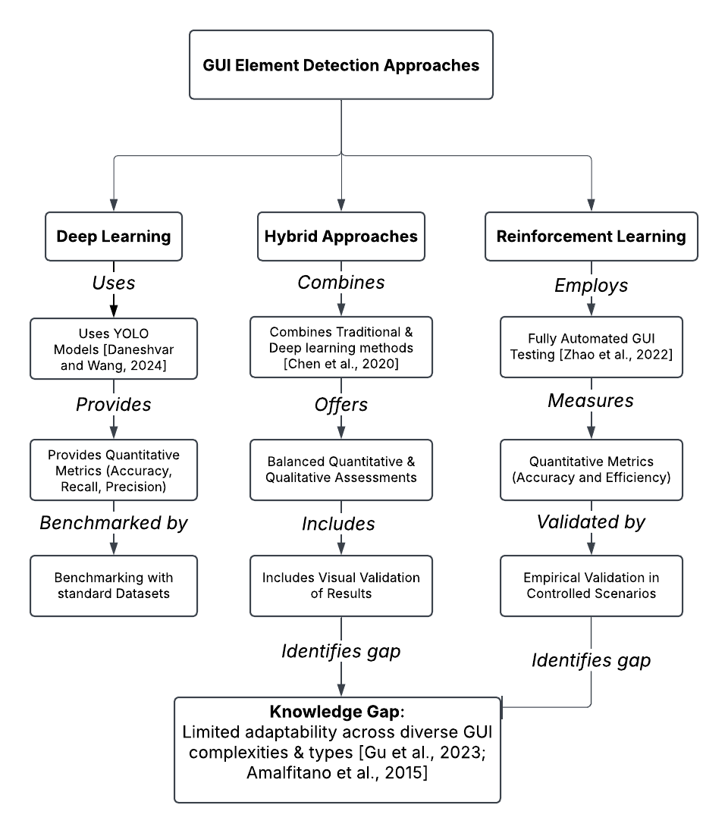

**Literature Map Explanation**

The structured map presents three key methodological branches identified from previous research: Deep Learning, Hybrid Approaches, and Reinforcement Learning. Each branch details the methodologies, validation methods, and types of data gathered by previous studies, clearly linked by labelled relationships.

**Deep Learning**

* Daneshvar and Wang (2024) employ YOLO based deep learning models, emphasizing robust quantitative metrics such as accuracy, recall, and precision. They systematically benchmark their results against standard datasets, validating their hypothesis on GUI detection effectiveness through empirical data [1].

**Hybrid Approaches**

* **Chen et al. (2020)** adopted a methodology combination including traditional image processing and deep learning methods, providing balanced quantitative and qualitative assessments. Their approach notably includes visual validation, bridging theoretical accuracy and real world applicability [2].

**Reinforcement Learning**

* Zhao et al. (2022) introduced automated GUI testing through reinforcement learning. Their research methodology prioritised quantitative metrics focusing on accuracy and efficiency, rigorously validated through controlled empirical scenarios [3].

**Knowledge Gap**

* The literature review identifies a critical knowledge gap: limited adaptability across diverse GUI complexities and types, highlighted by research from Gu et al. (2023) [4] and Amalfitano et al. (2015) [5]. Despite robust quantitative analyses, existing studies have not fully addressed adaptability to complex and dynamic interface variations. This gap underscores the potential for future research to explore and validate models in more diverse and practical situations.

**Reflection on the Chosen Methodology**

**Research Questions**

1. How accurately can OmniParser detect and classify various GUI elements from screenshots?
2. What level of efficiency, in terms of processing speed, does OmniParser offer for real time GUI detection?
3. How does GUI complexity affect the accuracy, efficiency, and reliability of OmniParser?

**Research Objectives**

1. Evaluate OmniParser’s detection accuracy across multiple GUI elements such as buttons, text fields, labels, and icons.
2. Measure and analyze OmniParser’s processing speed to determine its suitability for real time or near real time GUI detection.
3. Investigate the impact of GUI complexity on OmniParser’s performance.
4. Validate the reliability of OmniParser’s results through quantitative metrics and qualitative validation techniques.

**Understanding of Research Philosophies, Approaches, and Paradigms**

**Research Philosophy – Pragmatism:**Pragmatism emphasizes real world applicability, making it well suited for this study. By integrating both quantitative and qualitative methods, this philosophy ensures a practical assessment of OmniParser’s capabilities [4].

**Research Approach – Deductive:**A deductive approach is used, as this research is based on existing theories and prior empirical studies. Structured testing is conducted to validate predefined hypotheses, ensuring a rigorous methodological foundation.

**Research Paradigm – Experimental Mixed-Methods:**This study employs an experimental mixed-methods paradigm to provide measurable data (accuracy, precision, recall, processing speed) and qualitative insights through visual validation. This dual approach ensures both statistical robustness and practical relevance [5].

**Chosen Suitable Methodology Based on Literature Review**

**Experimental Mixed Methods Approach:**

* Selected for its ability to quantify OmniParser’s performance while allowing practical validation through structured visual assessments.
* Previous research [2]–[4] has demonstrated the reliability of combining quantitative performance benchmarks with qualitative evaluations in GUI automation.

**Initial Description of Methodology, Experiment Design, and Analysis**

**Experimental Design**

* **Data Collection:**
  + Publicly available GUI datasets such as ScreenSpot will be used, covering a range of interface complexities (simple, moderate, complex) [3].
  + These datasets ensure a credible benchmark for evaluating OmniParser’s real world applicability.
* **Sampling Approach:**
  + A diverse set of GUI screenshots will be selected to represent varying interface complexities, ensuring a robust validation process.

**Method of Analysis:**

* **Quantitative Analysis:**
  + OmniParser’s performance will be measured using well established metrics:
    - Accuracy, Precision, Recall, and F1 score to assess detection effectiveness [1],[2],[4].
    - Processing time per screenshot to evaluate real time feasibility.
* **Qualitative Analysis:**
  + Structured visual validation will ensure that OmniParser’s classifications align with human perception, strengthening empirical findings with practical usability insights.

**Reflections on Validity, Reliability & Generalizability**

**Validity:**

* Construct validity is ensured using peer reviewed datasets such as ScreenSpot.
* Qualitative validation aligns quantitative results with real world usability.

**Reliability:**

* Clear documentation and replicable experimental procedures ensure consistent results across tests.
* Standardized performance metrics (e.g., accuracy, recall, F1-score) further reinforce methodological reliability.

**Generalizability:**

* Testing across diverse GUI complexities enhances the research’s applicability to various real-world scenarios.
* Well documented replication guidelines ensure future studies can extend these findings.

**Ethical Considerations**

**Data Privacy:**

* Only publicly available, ethically vetted datasets will be used, ensuring no privacy violations.

**Research Transparency & Replicability:**

* Clear documentation of all methodologies ensures research integrity and facilitates independent verification.

**Bias & Fairness:**

* Diverse and representative datasets minimize bias, ensuring fair assessment across different GUI types.

**Integrity in Reporting:**

* Results will be reported accurately and without bias, clearly stating both strengths and limitations.

**References**

[1] S. S. Daneshvar and S. Wang, "GUI Element Detection Using SOTA YOLO Deep Learning Models," *arXiv preprint arXiv:2408.03507*, 2024. [Online]. Available: <https://arxiv.org/abs/2408.03507>

[2] Z. Chen, X. Xiao, and S. Gao, "Object Detection for Graphical User Interface: Old Fashioned or Deep Learning or a Combination?," *arXiv preprint arXiv:2008.05132*, 2020. [Online]. Available: <https://arxiv.org/abs/2008.05132>

[3] X. Zhao, Y. Cao, and M. Li, "Deep Reinforcement Learning for Automated GUI Testing," *IEEE Transactions on Software Engineering*, vol. 49, no. 5, pp. 1769–1784, 2022. [Online]. Available: <https://ieeexplore.ieee.org/document/9715282>

[4] Z. Gu et al., "Mobile User Interface Element Detection via Adaptively Prompt Tuning," *Proceedings of the IEEE/CVF Conference on Computer Vision and Pattern Recognition*, pp. 11155–11164, 2023. [Online]. Available: <https://openaccess.thecvf.com/content/CVPR2023/papers/Gu_Mobile_User_Interface_Element_Detection_via_Adaptively_Prompt_Tuning_CVPR_2023_paper.pdf>

[5] D. Amalfitano, A. R. Fasolino, P. Tramontana, and N. Amatucci, "Using Artificial Intelligence to Automatically Test GUI," *IEEE Software*, vol. 32, no. 5, pp. 46–53, 2015. [Online]. Available: <https://doi.org/10.1109/MS.2015.104>